Install Drive of Micro:bit Board
- First of all, connect the micro:bit to your computer using a USB cable.
，then double-click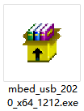to install.
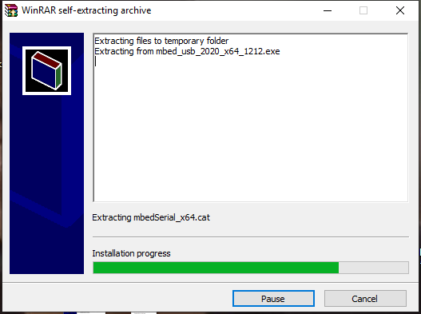
After downloading the driver, then click“Next”
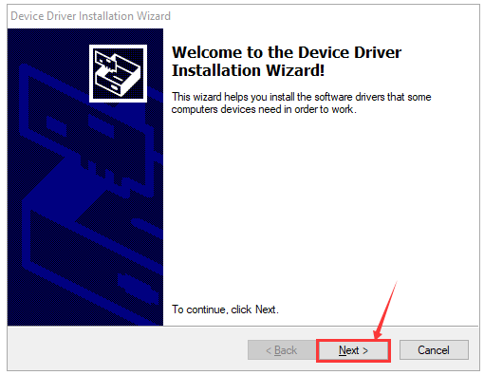
Click“Install”
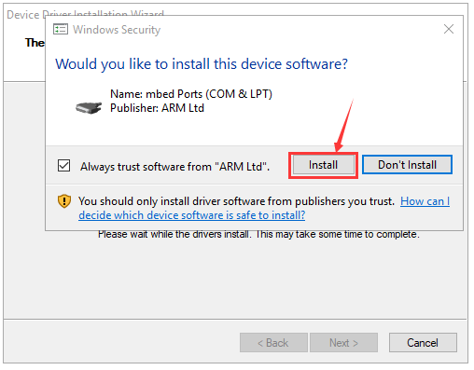

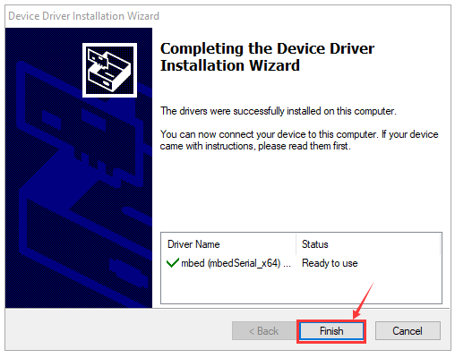
Tap“Finish”. Then click“Computer”—>“Properties”—>“Device manager”, as shown below.

